Name: Pranali Sonawane
Subject: MCSA
Date: 9-12-2025
Lab 7: Active Directory Domain Controller :
Server 1: Remove Service (DHCP):-
Add Role & Feature start Remove role next Remove DHCP Server next install Restart .
Give IP:
Server1: 192.168.10.1
Server2: 192.168.10.2
Client1: 192.168.10.3
Server2: Give IP:
- Local Server Ethernet0 Give IP 192.168.10.2 Disable then Enable .
- Check Firewall it’s should be OFF.
Client1:Give IP:
- Run ncpa.cpl Ethernet0 Give IP 192.168.10.3 Disable then Enable.
- Check Firewall it’s should be OFF. system Firewall type OFF.

Active Directory Domain Controller :
Server2:
Prerequisite:
- Give Static IP (Ping each other )
- Login on : Microsoft/Administrator

- Add role & Features next next select Active Directory add feature select DNS Server next restart install.
- Notes: Server2 local server Ethernet0 give Alternate DNS Server 192.168.10.2 ok
- Click on yellow mark config ADC Add a Domain Controller on Existing show Microsoft.com global catlog Password Replication select Server1.Microsoft.com next next install.
- Check: Tools Active Directory Users and Computer Computer show Client1
Direct Controller show server1 and server2.

In Server 1 create a group it’s automatically show on Server2 and vice versa.

- Remove Active Directory Domain Controller :
Server2:
Local server start to remove next click on Active directory Domain server and DNS Server Demote Proceed to Removal next next Demote Restart.

Local Server Domain server2 change Select Workgroup write W restart

Local Server Domain server2 change Select Domain write Microsoft.com username: Administrator and Password: Password@123

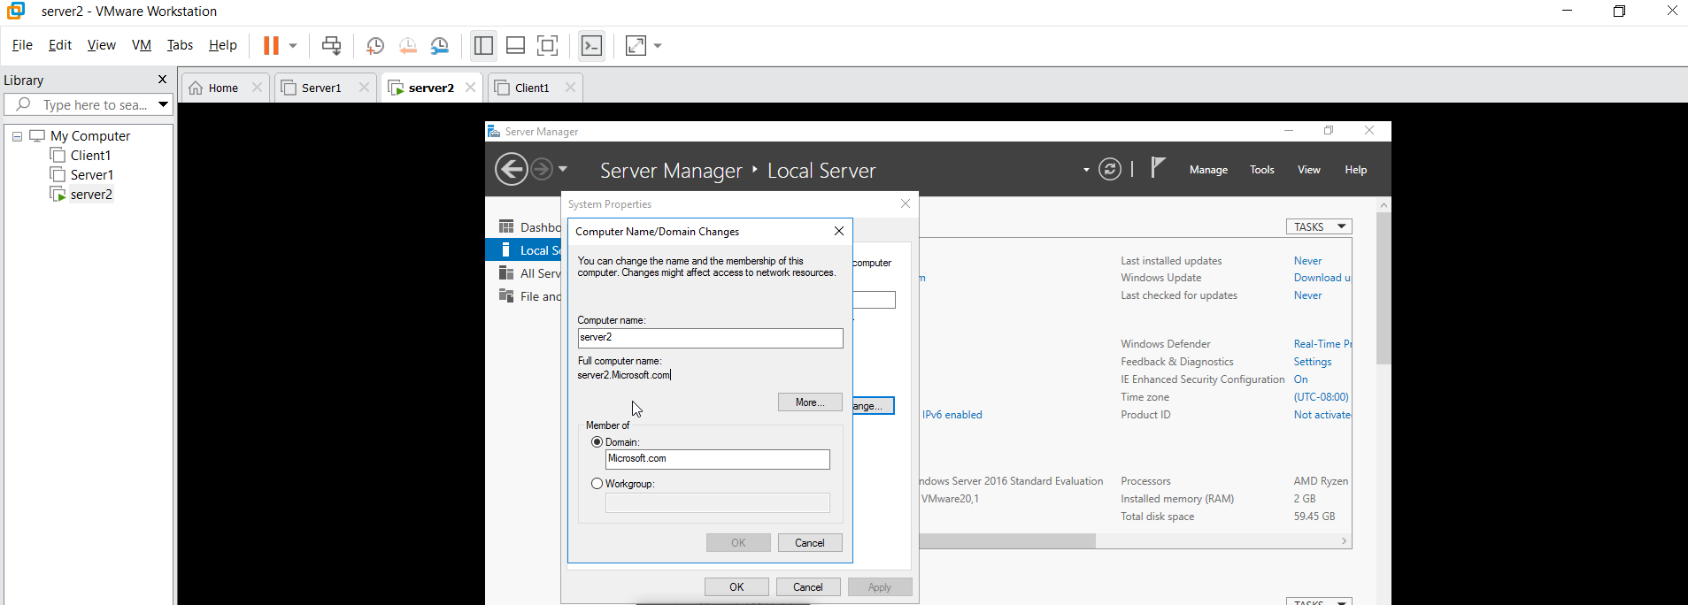
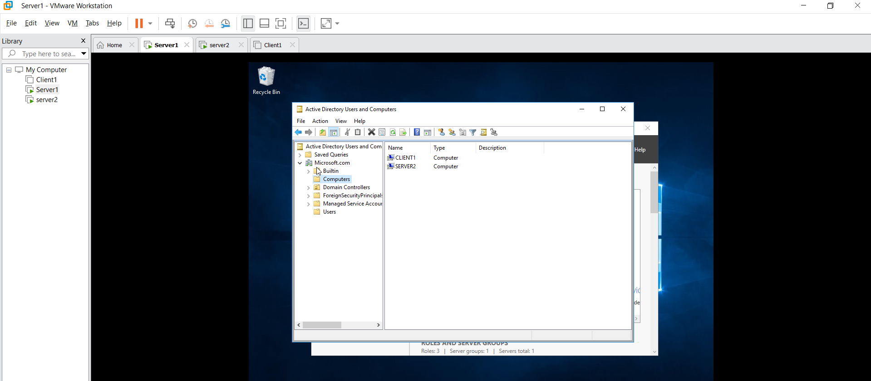
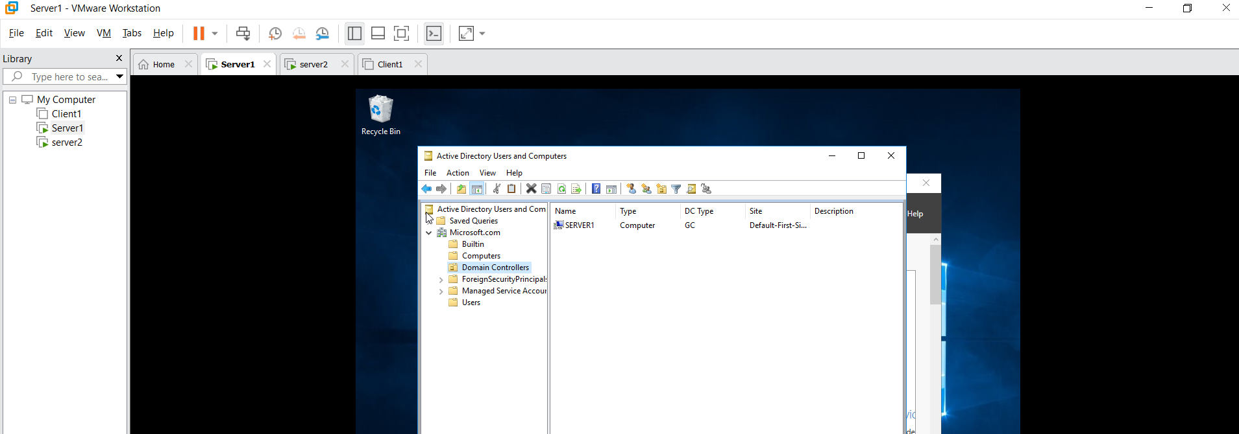
In Server 1 create a group it’s automatically show on Server2 and vice versa

